Case 2-Afr-Egy-Shabtis-EBAY 2016

|  |  |
| --- | --- |
| RDER DATEJan 29, 2016 | ORDER TOTAL  US $192.00  + US $85.00  shipping  **Order Ancient Egyptian yellow Ushabti ,Ancient Egyptian blue Ushabti ,Ancient Egyptian Blue Ushabti antiques,Ancient Egyptian blue Ushabti ,Ancient Egyptian 7 Amulets ,Ancient Egyptian 7 Amulets** [View order details - ORDER DATE Jan 29, 2016](http://payments.ebay.com/ws/eBayISAPI.dll?ViewPaymentStatus&transId=0&itemid=161959979042&_trksid=p2057872.m2749.l2673)[Contact seller](http://contact.ebay.com/ws/eBayISAPI.dll?ShowSellerFAQ&requested=amafamily12&iid=161959979042&redirect=0&_trksid=p2057872.m2749.l2652) - ORDER DATE Jan 29, 2016  [More actions - ORDER DATE Jan 29, 2016](http://www.ebay.com/myb/PurchaseHistory) |

6 items sold by [amafamily12](http://www.ebay.com/usr/amafamily12?_trksid=p2057872.m2749.l2754)

|  |  |  |
| --- | --- | --- |
| [Ancient Egyptian yellow Ushabti](http://www.ebay.com/itm/161959979042?_trksid=p2057872.m2749.l2649&ssPageName=STRK%3AMEBIDX%3AIT)  ( 161959979042 )  Estimated delivery Mon, Feb 22 - Mon, Feb 29  [Add note](javascript:;) | ITEM PRICE:  US $37.00 | **Item Ancient Egyptian yellow Ushabti Orders 161959979042-0-0**[Leave feedback](http://feedback.ebay.com/ws/eBayISAPI.dll?LeaveFeedbackShow&useridto=amafamily12&transactID=0&item=161959979042&_trksid=p2057872.m2749.l2665)[Return this item](http://postorder.ebay.com/Return/ReturnViewSelectedItem?transactionId=0&itemId=161959979042&_trksid=p2057872.m2749.l3185)  [More actions](http://www.ebay.com/myb/PurchaseHistory) |

|  |  |  |
| --- | --- | --- |
| [Ancient Egyptian blue Ushabti](http://www.ebay.com/itm/161959993919?_trksid=p2057872.m2749.l2649&ssPageName=STRK%3AMEBIDX%3AIT)  ( 161959993919 )  Estimated delivery Mon, Feb 22 - Mon, Feb 29  [Add note](javascript:;) | ITEM PRICE:  US $40.00 | **Item Ancient Egyptian blue Ushabti Orders 161959993919-0-0**[Leave feedback](http://feedback.ebay.com/ws/eBayISAPI.dll?LeaveFeedbackShow&useridto=amafamily12&transactID=0&item=161959993919&_trksid=p2057872.m2749.l2665)[Return this item](http://postorder.ebay.com/Return/ReturnViewSelectedItem?transactionId=0&itemId=161959993919&_trksid=p2057872.m2749.l3185)  [More actions](http://www.ebay.com/myb/PurchaseHistory) |

|  |  |  |
| --- | --- | --- |
| [Ancient Egyptian Blue Ushabti antiques](http://www.ebay.com/itm/161960003661?_trksid=p2057872.m2749.l2649&ssPageName=STRK%3AMEBIDX%3AIT)  ( 161960003661 )  Estimated delivery Mon, Feb 22 - Mon, Feb 29  [Add note](javascript:;) | ITEM PRICE:  US $35.00 | **Item Ancient Egyptian Blue Ushabti antiques Orders 161960003661-0-0**[Leave feedback](http://feedback.ebay.com/ws/eBayISAPI.dll?LeaveFeedbackShow&useridto=amafamily12&transactID=0&item=161960003661&_trksid=p2057872.m2749.l2665)[Return this item](http://postorder.ebay.com/Return/ReturnViewSelectedItem?transactionId=0&itemId=161960003661&_trksid=p2057872.m2749.l3185)  [More actions](http://www.ebay.com/myb/PurchaseHistory) |

|  |  |  |
| --- | --- | --- |
| [Ancient Egyptian blue Ushabti](http://www.ebay.com/itm/161960005542?_trksid=p2057872.m2749.l2649&ssPageName=STRK%3AMEBIDX%3AIT)  ( 161960005542 )  Estimated delivery Mon, Feb 22 - Mon, Feb 29  [Add note](javascript:;) | ITEM PRICE:  US $20.00 | **Item Ancient Egyptian blue Ushabti Orders 161960005542-0-0**[Leave feedback](http://feedback.ebay.com/ws/eBayISAPI.dll?LeaveFeedbackShow&useridto=amafamily12&transactID=0&item=161960005542&_trksid=p2057872.m2749.l2665)[Return this item](http://postorder.ebay.com/Return/ReturnViewSelectedItem?transactionId=0&itemId=161960005542&_trksid=p2057872.m2749.l3185)  [More actions](http://www.ebay.com/myb/PurchaseHistory) |

|  |  |  |
| --- | --- | --- |
| [Ancient Egyptian 7 Amulets](http://www.ebay.com/itm/161960013668?_trksid=p2057872.m2749.l2649&ssPageName=STRK%3AMEBIDX%3AIT)  ( 161960013668 )  Estimated delivery Mon, Feb 22 - Mon, Feb 29  [Add note](javascript:;) | ITEM PRICE:  US $30.00 | **Item Ancient Egyptian 7 Amulets Orders 161960013668-0-0**[Leave feedback](http://feedback.ebay.com/ws/eBayISAPI.dll?LeaveFeedbackShow&useridto=amafamily12&transactID=0&item=161960013668&_trksid=p2057872.m2749.l2665)[Return this item](http://postorder.ebay.com/Return/ReturnViewSelectedItem?transactionId=0&itemId=161960013668&_trksid=p2057872.m2749.l3185)  [More actions](http://www.ebay.com/myb/PurchaseHistory) |

|  |  |  |  |  |  |
| --- | --- | --- | --- | --- | --- |
| [Ancient Egyptian 7 Amulets](http://www.ebay.com/itm/161960017622?_trksid=p2057872.m2749.l2649&ssPageName=STRK%3AMEBIDX%3AIT)  ( 161960017622 )  Estimated delivery Mon, Feb 22 - Mon, Feb 29  [Add note](javascript:;) | | | | ITEM PRICE:  US $30.00 | **Item Ancient Egyptian 7 Amulets Orders 161960017622-0-0**[Leave feedback](http://feedback.ebay.com/ws/eBayISAPI.dll?LeaveFeedbackShow&useridto=amafamily12&transactID=0&item=161960017622&_trksid=p2057872.m2749.l2665)[Return this item](http://postorder.ebay.com/Return/ReturnViewSelectedItem?transactionId=0&itemId=161960017622&_trksid=p2057872.m2749.l3185) |
|  | ORDER DATEDec 22, 2015 | ORDER TOTAL  US $43.00  + US $20.00  shipping  **Order Ancient Egyptian blue Ushabti antiques,Ancient Egyptian Blue Ushabti antiques** [View order details - ORDER DATE Dec 22, 2015](http://payments.ebay.com/ws/eBayISAPI.dll?ViewPaymentStatus&transId=0&itemid=161923093700&_trksid=p2057872.m2749.l2673)[Contact seller](http://contact.ebay.com/ws/eBayISAPI.dll?ShowSellerFAQ&requested=amafamily12&iid=161923093700&redirect=0&_trksid=p2057872.m2749.l2652) - ORDER DATE Dec 22, 2015  [More actions - ORDER DATE Dec 22, 2015](http://www.ebay.com/myb/PurchaseHistory) |  | | |

2 items sold by [amafamily12](http://www.ebay.com/usr/amafamily12?_trksid=p2057872.m2749.l2754)

|  |  |  |
| --- | --- | --- |
| [Ancient Egyptian blue Ushabti antiques](http://www.ebay.com/itm/161923093700?_trksid=p2057872.m2749.l2649&ssPageName=STRK%3AMEBIDX%3AIT)  ( 161923093700 )  Estimated delivery Thu, Jan 14 - Thu, Jan 21  [Add note](javascript:;) | ITEM PRICE:  US $20.00 | **Item Ancient Egyptian blue Ushabti antiques Orders 161923093700-0-0**[Leave feedback](http://feedback.ebay.com/ws/eBayISAPI.dll?LeaveFeedbackShow&useridto=amafamily12&transactID=0&item=161923093700&_trksid=p2057872.m2749.l2665)[Return this item](http://postorder.ebay.com/Return/ReturnViewSelectedItem?transactionId=0&itemId=161923093700&_trksid=p2057872.m2749.l3185)  [More actions](http://www.ebay.com/myb/PurchaseHistory) |

|  |  |  |
| --- | --- | --- |
| [Ancient Egyptian Blue Ushabti antiques](http://www.ebay.com/itm/161923098286?_trksid=p2057872.m2749.l2649&ssPageName=STRK%3AMEBIDX%3AIT)  ( 161923098286 )  Estimated delivery Thu, Jan 14 - Thu, Jan 21  [Add note](javascript:;) | ITEM PRICE:  US $23.00 | **Item Ancient Egyptian Blue Ushabti antiques Orders 161923098286-0-0**[Leave feedback](http://feedback.ebay.com/ws/eBayISAPI.dll?LeaveFeedbackShow&useridto=amafamily12&transactID=0&item=161923098286&_trksid=p2057872.m2749.l2665)[Return this item](http://postorder.ebay.com/Return/ReturnViewSelectedItem?transactionId=0&itemId=161923098286&_trksid=p2057872.m2749.l3185)  [More actions](http://www.ebay.com/myb/PurchaseHistory) |

|  |  |
| --- | --- |
| ORDER DATEDec 22, 2015 | ORDER TOTAL  US $110.50  + US $35.00  shipping  **Order Ancient Egyptian green Ushabti,Ancient Egyptian 5 Amulets antiques,Ancient Egyptian 5 Amulets antiques,Ancient Egyptian 6 Amulets antiques** [View order details - ORDER DATE Dec 22, 2015](http://payments.ebay.com/ws/eBayISAPI.dll?ViewPaymentStatus&transId=0&itemid=161923106584&_trksid=p2057872.m2749.l2673)[Contact seller](http://contact.ebay.com/ws/eBayISAPI.dll?ShowSellerFAQ&requested=amafamily12&iid=161923106584&redirect=0&_trksid=p2057872.m2749.l2652) - ORDER DATE Dec 22, 2015  [More actions - ORDER DATE Dec 22, 2015](http://www.ebay.com/myb/PurchaseHistory) |

4 items sold by [amafamily12](http://www.ebay.com/usr/amafamily12?_trksid=p2057872.m2749.l2754)

|  |  |  |
| --- | --- | --- |
| [Ancient Egyptian green Ushabti](http://www.ebay.com/itm/161923106584?_trksid=p2057872.m2749.l2649&ssPageName=STRK%3AMEBIDX%3AIT)  ( 161923106584 )  Estimated delivery Thu, Jan 14 - Thu, Jan 21  [Add note](javascript:;) | ITEM PRICE:  US $18.50 | **Item Ancient Egyptian green Ushabti Orders 161923106584-0-0**[Leave feedback](http://feedback.ebay.com/ws/eBayISAPI.dll?LeaveFeedbackShow&useridto=amafamily12&transactID=0&item=161923106584&_trksid=p2057872.m2749.l2665)[Return this item](http://postorder.ebay.com/Return/ReturnViewSelectedItem?transactionId=0&itemId=161923106584&_trksid=p2057872.m2749.l3185)  [More actions](http://www.ebay.com/myb/PurchaseHistory) |

|  |  |  |
| --- | --- | --- |
| [Ancient Egyptian 5 Amulets antiques](http://www.ebay.com/itm/161923109147?_trksid=p2057872.m2749.l2649&ssPageName=STRK%3AMEBIDX%3AIT)  ( 161923109147 )  Estimated delivery Thu, Jan 14 - Thu, Jan 21  [Add note](javascript:;) | ITEM PRICE:  US $37.00 | **Item Ancient Egyptian 5 Amulets antiques Orders 161923109147-0-0**[Leave feedback](http://feedback.ebay.com/ws/eBayISAPI.dll?LeaveFeedbackShow&useridto=amafamily12&transactID=0&item=161923109147&_trksid=p2057872.m2749.l2665)[Return this item](http://postorder.ebay.com/Return/ReturnViewSelectedItem?transactionId=0&itemId=161923109147&_trksid=p2057872.m2749.l3185)  [More actions](http://www.ebay.com/myb/PurchaseHistory) |

|  |  |  |
| --- | --- | --- |
| [Ancient Egyptian 5 Amulets antiques](http://www.ebay.com/itm/161923110016?_trksid=p2057872.m2749.l2649&ssPageName=STRK%3AMEBIDX%3AIT)  ( 161923110016 )  Estimated delivery Thu, Jan 14 - Thu, Jan 21  [Add note](javascript:;) | ITEM PRICE:  US $25.00 | **Item Ancient Egyptian 5 Amulets antiques Orders 161923110016-0-0**[Leave feedback](http://feedback.ebay.com/ws/eBayISAPI.dll?LeaveFeedbackShow&useridto=amafamily12&transactID=0&item=161923110016&_trksid=p2057872.m2749.l2665)[Return this item](http://postorder.ebay.com/Return/ReturnViewSelectedItem?transactionId=0&itemId=161923110016&_trksid=p2057872.m2749.l3185)  [More actions](http://www.ebay.com/myb/PurchaseHistory) |

|  |  |  |
| --- | --- | --- |
| [Ancient Egyptian 6 Amulets antiques](http://www.ebay.com/itm/161923111059?_trksid=p2057872.m2749.l2649&ssPageName=STRK%3AMEBIDX%3AIT)  ( 161923111059 )  Estimated delivery Thu, Jan 14 - Thu, Jan 21  [Add note](javascript:;) | ITEM PRICE:  US $30.00 | **Item Ancient Egyptian 6 Amulets antiques Orders 161923111059-0-0**[Leave feedback](http://feedback.ebay.com/ws/eBayISAPI.dll?LeaveFeedbackShow&useridto=amafamily12&transactID=0&item=161923111059&_trksid=p2057872.m2749.l2665)[Return this item](http://postorder.ebay.com/Return/ReturnViewSelectedItem?transactionId=0&itemId=161923111059&_trksid=p2057872.m2749.l3185)  [More actions](http://www.ebay.com/myb/PurchaseHistory) |

|  |  |
| --- | --- |
| ORDER DATEDec 22, 2015 | ORDER TOTAL  US $45.00  + US $20.00  shipping  **Order Ancient Egyptian Ushabti antiques,Ancient Egyptian Blue Ushabti antiques** [View order details - ORDER DATE Dec 22, 2015](http://payments.ebay.com/ws/eBayISAPI.dll?ViewPaymentStatus&transId=0&itemid=161923073895&_trksid=p2057872.m2749.l2673)[Contact seller](http://contact.ebay.com/ws/eBayISAPI.dll?ShowSellerFAQ&requested=amafamily12&iid=161923073895&redirect=0&_trksid=p2057872.m2749.l2652) - ORDER DATE Dec 22, 2015  [More actions - ORDER DATE Dec 22, 2015](http://www.ebay.com/myb/PurchaseHistory) |

2 items sold by [amafamily12](http://www.ebay.com/usr/amafamily12?_trksid=p2057872.m2749.l2754)

|  |  |  |
| --- | --- | --- |
| [Ancient Egyptian Ushabti antiques](http://www.ebay.com/itm/161923073895?_trksid=p2057872.m2749.l2649&ssPageName=STRK%3AMEBIDX%3AIT)  ( 161923073895 )  Estimated delivery Thu, Jan 14 - Thu, Jan 21  [Add note](javascript:;) | ITEM PRICE:  US $25.00 | **Item Ancient Egyptian Ushabti antiques Orders 161923073895-0-0**[Leave feedback](http://feedback.ebay.com/ws/eBayISAPI.dll?LeaveFeedbackShow&useridto=amafamily12&transactID=0&item=161923073895&_trksid=p2057872.m2749.l2665)[Return this item](http://postorder.ebay.com/Return/ReturnViewSelectedItem?transactionId=0&itemId=161923073895&_trksid=p2057872.m2749.l3185)  [More actions](http://www.ebay.com/myb/PurchaseHistory) |

|  |  |  |
| --- | --- | --- |
| [Ancient Egyptian Blue Ushabti antiques](http://www.ebay.com/itm/161923077618?_trksid=p2057872.m2749.l2649&ssPageName=STRK%3AMEBIDX%3AIT)  ( 161923077618 )  Estimated delivery Thu, Jan 14 - Thu, Jan 21  [Add note](javascript:;) | ITEM PRICE:  US $20.00 | **Item Ancient Egyptian Blue Ushabti antiques Orders 161923077618-0-0**[Leave feedback](http://feedback.ebay.com/ws/eBayISAPI.dll?LeaveFeedbackShow&useridto=amafamily12&transactID=0&item=161923077618&_trksid=p2057872.m2749.l2665)[Return this item](http://postorder.ebay.com/Return/ReturnViewSelectedItem?transactionId=0&itemId=161923077618&_trksid=p2057872.m2749.l3185)  [More actions](http://www.ebay.com/myb/PurchaseHistory) |

|  |  |
| --- | --- |
| ORDER DATEDec 22, 2015 | ORDER TOTAL  US $48.53  + US $15.00  shipping  **Order Ancient Egyptian Ushabti antiques of God Bes,Ancient Egyptian Blue Ushabti antiques** [View order details - ORDER DATE Dec 22, 2015](http://payments.ebay.com/ws/eBayISAPI.dll?ViewPaymentStatus&transId=0&itemid=161922800704&_trksid=p2057872.m2749.l2673)[Contact seller](http://contact.ebay.com/ws/eBayISAPI.dll?ShowSellerFAQ&requested=amafamily12&iid=161922800704&redirect=0&_trksid=p2057872.m2749.l2652) - ORDER DATE Dec 22, 2015  [More actions - ORDER DATE Dec 22, 2015](http://www.ebay.com/myb/PurchaseHistory) |

2 items sold by [amafamily12](http://www.ebay.com/usr/amafamily12?_trksid=p2057872.m2749.l2754)

|  |  |  |
| --- | --- | --- |
| [Ancient Egyptian Ushabti antiques of God Bes](http://www.ebay.com/itm/161922800704?_trksid=p2057872.m2749.l2649&ssPageName=STRK%3AMEBIDX%3AIT)  ( 161922800704 )  Estimated delivery Thu, Jan 14 - Thu, Jan 21  [Add note](javascript:;) | ITEM PRICE:  US $15.00 | **Item Ancient Egyptian Ushabti antiques of God Bes Orders 161922800704-0-0**[Leave feedback](http://feedback.ebay.com/ws/eBayISAPI.dll?LeaveFeedbackShow&useridto=amafamily12&transactID=0&item=161922800704&_trksid=p2057872.m2749.l2665)[Return this item](http://postorder.ebay.com/Return/ReturnViewSelectedItem?transactionId=0&itemId=161922800704&_trksid=p2057872.m2749.l3185)  [More actions](http://www.ebay.com/myb/PurchaseHistory) |

|  |  |  |
| --- | --- | --- |
| [Ancient Egyptian Blue Ushabti antiques](http://www.ebay.com/itm/161923066755?_trksid=p2057872.m2749.l2649&ssPageName=STRK%3AMEBIDX%3AIT)  ( 161923066755 )  Estimated delivery Thu, Jan 14 - Thu, Jan 21  [Add note](javascript:;) | ITEM PRICE:  US $33.53 | **Item Ancient Egyptian Blue Ushabti antiques Orders 161923066755-0-0**[Leave feedback](http://feedback.ebay.com/ws/eBayISAPI.dll?LeaveFeedbackShow&useridto=amafamily12&transactID=0&item=161923066755&_trksid=p2057872.m2749.l2665)[Return this item](http://postorder.ebay.com/Return/ReturnViewSelectedItem?transactionId=0&itemId=161923066755&_trksid=p2057872.m2749.l3185)  [More actions](http://www.ebay.com/myb/PurchaseHistory) |

|  |  |
| --- | --- |
| ORDER DATEDec 21, 2015 | ORDER TOTAL  US $61.00  + US $25.00  shipping  **Order Ancient Egyptian Blue Ushabti antiques of God Anubis,Ancient Egyptian Yellow Ushabti antiques** [View order details - ORDER DATE Dec 21, 2015](http://payments.ebay.com/ws/eBayISAPI.dll?ViewPaymentStatus&transId=0&itemid=221972542593&_trksid=p2057872.m2749.l2673)[Contact seller](http://contact.ebay.com/ws/eBayISAPI.dll?ShowSellerFAQ&requested=slisli4&iid=221972542593&redirect=0&_trksid=p2057872.m2749.l2652) - ORDER DATE Dec 21, 2015  [More actions - ORDER DATE Dec 21, 2015](http://www.ebay.com/myb/PurchaseHistory) |

2 items sold by [slisli4](http://www.ebay.com/usr/slisli4?_trksid=p2057872.m2749.l2754)

|  |  |  |
| --- | --- | --- |
| [Ancient Egyptian Blue Ushabti antiques of God Anubis](http://www.ebay.com/itm/221972542593?_trksid=p2057872.m2749.l2649&ssPageName=STRK%3AMEBIDX%3AIT)  ( 221972542593 )  Estimated delivery Thu, Jan 14 - Thu, Jan 21  [Add note](javascript:;) | ITEM PRICE:  US $41.00 | **Item Ancient Egyptian Blue Ushabti antiques of God Anubis Orders 221972542593-0-0**[Leave feedback](http://feedback.ebay.com/ws/eBayISAPI.dll?LeaveFeedbackShow&useridto=slisli4&transactID=0&item=221972542593&_trksid=p2057872.m2749.l2665)[Return this item](http://postorder.ebay.com/Return/ReturnViewSelectedItem?transactionId=0&itemId=221972542593&_trksid=p2057872.m2749.l3185)  [More actions](http://www.ebay.com/myb/PurchaseHistory) |

|  |  |  |
| --- | --- | --- |
| [Ancient Egyptian Yellow Ushabti antiques](http://www.ebay.com/itm/221972558965?_trksid=p2057872.m2749.l2649&ssPageName=STRK%3AMEBIDX%3AIT)  ( 221972558965 )  Estimated delivery Thu, Jan 14 - Thu, Jan 21  [Add note](javascript:;) | ITEM PRICE:  US $20.00 | **Item Ancient Egyptian Yellow Ushabti antiques Orders 221972558965-0-0**[Leave feedback](http://feedback.ebay.com/ws/eBayISAPI.dll?LeaveFeedbackShow&useridto=slisli4&transactID=0&item=221972558965&_trksid=p2057872.m2749.l2665)[Return this item](http://postorder.ebay.com/Return/ReturnViewSelectedItem?transactionId=0&itemId=221972558965&_trksid=p2057872.m2749.l3185)  [More actions](http://www.ebay.com/myb/PurchaseHistory) |

DIS-Afr-Egy-Ushabti-Flinders Petri

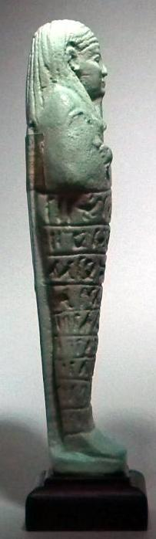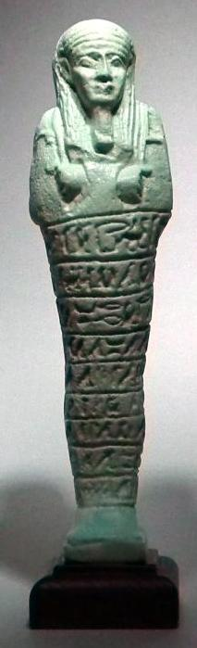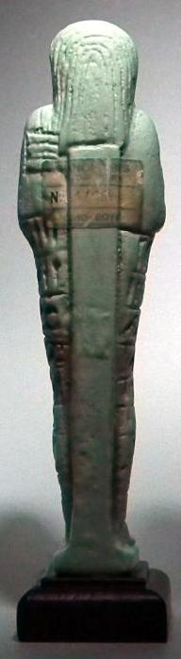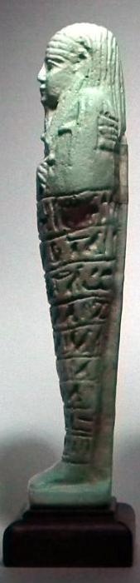

This very finely molded Ushabti Figure is typical of the style placed in ancient Egyptian burials during the 26th dynasty. The artifact has a superb pale blue-green color, a long striated wig, a plaited beard and is inscribed with the Saite version of chapter six of the Book of the Dead in nine horizontal registers of hieroglyphs. It was believed that the recitation of this text would bring such figures to life to carry out the agricultural duties demanded of its dead master in the afterlife. In readiness, the piece carries a pick, an adze and behind its left shoulder, a seed basket. A brilliant opportunity to own a valuable counterfeit by the retired and highly acclaimed British art forger John Andrews. Auctioned at a fraction of the cost of the real thing!

DIMENSIONS:  
Height: 6.5 inches (165 mm). Height with Plinth: 7.2 inches (183 mm). An intact and very rare museum quality example complete with attached labeling and invoice addressed to Flinders Petrie at the Semiramis Hotel, Cairo 1926.

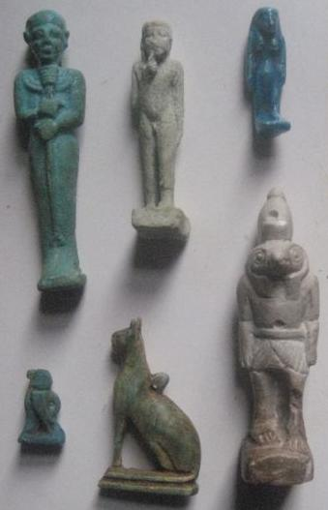

|  |  |
| --- | --- |
| Order details |  |
|  |  |
| Payment details |  |
|  |  |

|  |
| --- |
| Shipping details |
| **Ralph J Coffman Jr**  149 Atlantic Ave  Swampscott MA 01907-2427  United States |

## Order details

|  |  |  |  |
| --- | --- | --- | --- |
| **Item title** | **Available actions** | **Shipping & handling (estimated delivery*)** | **Price** |

[Printer version](http://payments.ebay.com/ws/eBayISAPI.dll?ViewPaymentStatus&transid=0&userloginid=802-867&printerversion=true&itemid=390515814566)

|  |  |  |
| --- | --- | --- |
| Seller: | [**Member id** russelliott](http://myworld.ebay.com/russelliott) ( [**Feedback Score Of** 4486](http://feedback.ebay.com/ws/eBayISAPI.dll?ViewFeedback&userid=russelliott)) | [Contact seller](http://contact.ebay.com/ws/eBayISAPI.dll?ShowCoreAskSellerQuestion&frm=3998&iid=390515814566&redirect=0&requested=russelliott) |

|  |  |  |  |  |
| --- | --- | --- | --- | --- |
| Your Dec-23-12 payment is being processed through PayPal | | | | |
|  |  |  |  |  |

|  |  |  |  |  |  |  |  |  |
| --- | --- | --- | --- | --- | --- | --- | --- | --- |
|  | [**Item Title:**Authentic Ancient Egyptian Baby Horus & Shabti Figurines**- opens in a new window or tab**](http://cgi.ebay.com/ws/eBayISAPI.dll?ViewItem&item=390515814566)  **Item Id:**390515814566 - Price: GBP 207.55  Quantity:1  Having a problem with this purchase? [We can help](javascript:;) | |  | | --- | |  | | |  |  | | --- | --- | | [View PayPal transaction**- opens in a new window or tab**](http://payments.ebay.com/ws/eBayISAPI.dll?IntermediateResolutionInfo&qs=transid%3D0%26buyerorseller%3D0%26sspagename%3DBuyTransCS%26itemid%3D390515814566&transid=0&pn=UnifiedCheckoutSummaryRedirect2PP&itemid=390515814566) |  | | | Standard Int'l Postage : **GBP 9.99**  Estimated delivery: Varies* You can [contact the seller](http://contact.ebay.com/ws/eBayISAPI.dll?ShowCoreAskSellerQuestion&frm=3998&iid=390515814566&SSpagename=PageAskSellerQuestion_VI&redirect=0&requested=russelliott) for more information. | GBP 207.55 |



|  |  |  |  |  |
| --- | --- | --- | --- | --- |
|  | | |  | |
|  |  | |  |  |  |  |  |  |  |  |  |  |  |  |  |  |  |  |  |  | | --- | --- | --- | --- | --- | --- | --- | --- | --- | --- | --- | --- | --- | --- | --- | --- | --- | --- | | |  | | --- | | |  |  |  |  |  |  |  |  |  |  |  |  |  |  |  | | --- | --- | --- | --- | --- | --- | --- | --- | --- | --- | --- | --- | --- | --- | --- | | |  |  | | --- | --- | | Subtotal: | GBP 207.55 | |  | | | Shipping & handling: | GBP 9.99 | |  | | |  | | |  | | | Total: | GBP 217.54 | | | | | |  |
|  |  |  | |  |

# Order details

## Sales order

Sold by [shoukhann](http://myworld.ebay.com/shoukhann) ( [476](http://feedback.ebay.com/ws/eBayISAPI.dll?ViewFeedback&userid=shoukhann) )

### Delivery package 1 of 1

Estimated delivery Monday, Feb 8, 2016

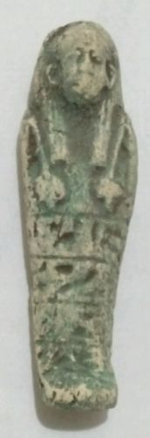

#### [Ancient Egyptian USHABTI Amulet 300 BC RARE](http://www.ebay.com/itm/222005219953)

|  |  |
| --- | --- |
| Item price | $22.50 |
| Quantity | 1 |
| Item number | 222005219953 |
| Shipping service | Economy Shipping |

No estimate available

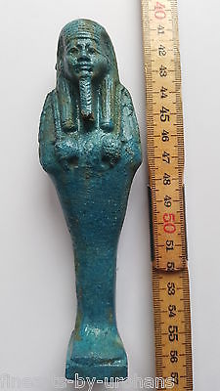

#### [BEAUTIFUL EGYPTIAN FAIENCE STYLE USHABTI / SHABTI. EXTREMELY NICE.](http://www.ebay.com/itm/331745442971)

|  |  |
| --- | --- |
| Item price | GBP 35.00 |
| Quantity | 1 |
| Item number | 331745442971 |
| Shipping service | Standard Int'l Postage |

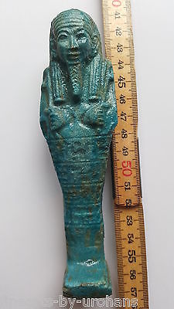

#### [BEAUTIFUL EGYPTIAN FAIENCE STYLE USHABTI / SHABTI. EXTREMELY NICE.](http://www.ebay.com/itm/331745445051)

|  |  |
| --- | --- |
| Item price | GBP 35.00 |
| Quantity | 1 |
| Item number | 331745445051 |
| Shipping service | Standard Int'l Postage |